Nagwa Aboelftouh

4221150

C1

**Get customers that its contactFirstName starts with 'je' or ‘le’.**

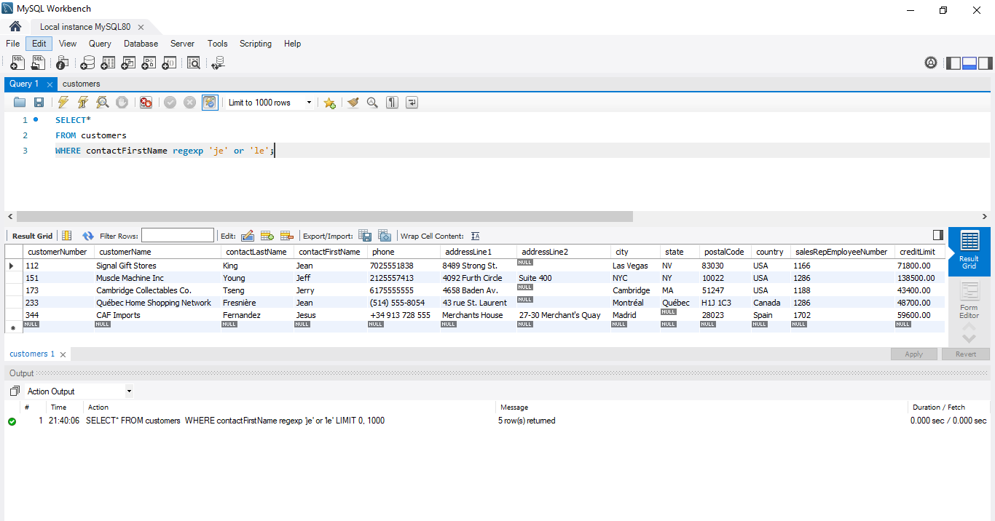

**Get customers that its contact First Name is ended with 'el' or contains ‘ie’.**

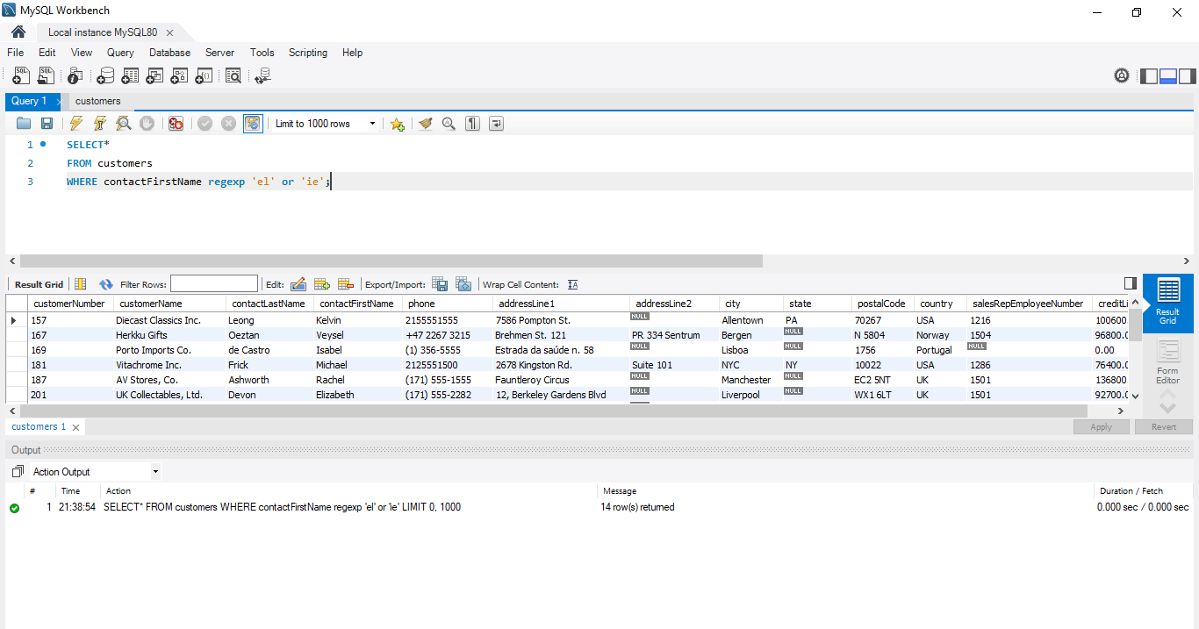

**Get customers that its contactFirstName contains 'b' followed by g or a.**

